Certified Translator
Candidate Instructions

OFFICIAL
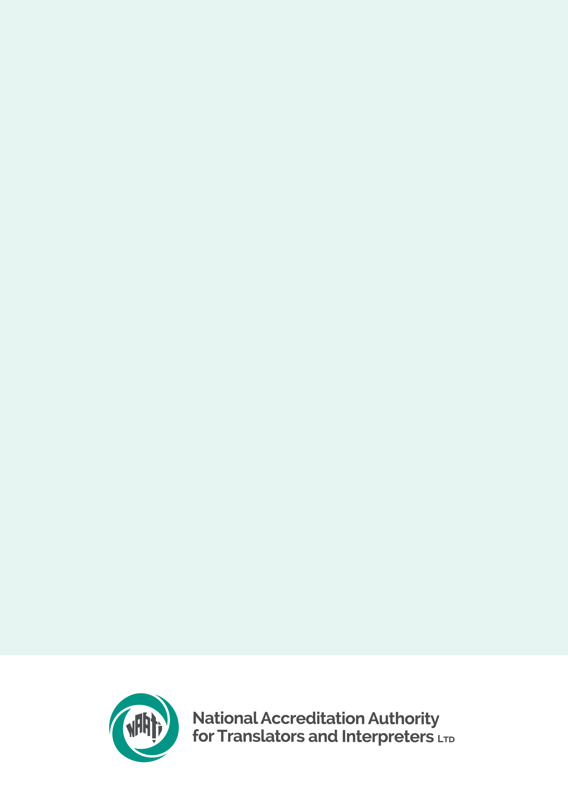

Contents
Certified Translator Candidate Instructions 1
Reminder for candidates 3
Equipment & system requirements 3
Preparing for test day 4
What you need to do before test day 4
Completing a system check 4
Sample materials & test preparation 4
What you will need 5
Identity document 5
Resources 5
What NAATI will & will not provide 6
Test conditions 6
Leaving the test venue 6
Behaviour on test day 7
Test materials 7
Use of electronic devices 7
Confidentiality 7
Test overview 8
Test description 8
Domains & topics 8
Duration 8
Sitting the test 9
Setting up on test day 9
Two translations of a non-specialised text tasks 9
One revision of a non-specialised translation task 10
Assessment & results 11
Assessment 11
Results & receiving your credential 11
Supplementary testing 11

Reminder for candidates
- Familiarise yourself with the Certified Translator test page
< https://www.naati.com.au/certification/ct/ >
- Read the Terms and conditions < https://www.naati.com.au/resources/terms-and-conditions/ >
- Understand the assessment process including how NAATI will assess your language use.

Equipment & system requirements
Please read the specifications carefully below.
You will need the following to sit this test:
Laptop or computer with the following:
- Working camera and microphone.
- A power cord/connector.
- Windows 10 or higher, Mac OS 11 (Big Sur) or higher, ChromeOS and most Linux distributions (64-bit Ubuntu 14.04+, Debian 8+, openSUSE 13.3+, or Fedora Linux 24+).
- Latest version of Google Chrome browser installed.
- You will be prompted to download and install the ProctorExam Google Chrome extension during your system check.
- Note: The test platform requires the use of Google products. Candidates must be able to access and use these without interference to sit the test. A work laptop or computer may block access to the test platform, restricting access to the platform.
Phone or tablet (in addition to the laptop or computer):
- With a working camera
- You will be prompted to download and install the ProctorExam app (34MB) during your system check. This app is compatible with Android 4.1 or higher or iOS (Apple) 10 or higher.
- Note: Huawei P30, Google Pixel, Sony Xperia, Iphone 6 and OnePlus are not compatible with the ProctorExam app.
Internet connection:
- At least 25mbps download speed, 10mbps upload speed, and internet speed (ping) of below 25 milliseconds
- You can check your internet speed on < www.speedtest.net >
- Note: using a public WiFi network or computer with firewalls (such as a work or laptop computer) that block access to the test platform may result in access to the test being restricted.
Other items:
- A power cord/connector
- Any software or input tools you need to type in your Language Other Than English (LOTE) installed, with ability to use offline. You should test your computer’s configuration prior to test day
- Any resources you intend to use during the test
- Note: You can find information about language input tools in the Support section of the Microsoft and Apple websites.
It is your responsibility to make sure your equipment is suitable and will function for the entire test. Failure to do so may result in your test being invalidated or cancelled with no refund. We recommend that your electronic devices be connected to a power source for the duration of your test. Note that small screens (such as laptop screens) may make it harder for you to see everything clearly.

Preparing for test day

What you need to do before test day

Completing a system check
The Certified Translator test is delivered online via NAATI’s testing platform, Televic. NAATI uses an online proctoring program called ProctorExam to make sure all tests are valid and are sat by the correct person.
Make sure you have the right equipment (see above).
Candidates with test sessions will receive an email approximately one week before the test day from ProctorExam with a link to the online platform and instructions on how to set up for your test.
When you click the link, you will be prompted to complete a system check. The system check must be completed using the same setup as you will use on your test day (i.e. same computer, phone, location, internet connection).
If you have not received this email from ProctorExam, check your spam/junk folder. If it is not there, please email us at onlinetesting@naati.com.au so that we can follow up for you.
Watch the video here for system check instructions: < https://youtu.be/tUPCHT66CWo >
Please note: This video refers to the use of headphones, but please disregard this. Headphones are not allowed in this test.
You will also need to set up the spell check functionality in Google Chrome which you will have access to for your test. < https://www.naati.com.au/resources/set-up-spell-check-chrome/ >
NAATI cannot guarantee that all languages are supported with this spell check function. Non-alphabetic or character-based languages may not be supported.

Sample materials & test preparation
We have a Certified Translator test preparation module available on our learning management system, NAATI Learn < https://learn.naati.com.au/ > , and anyone can access it for free.
It provides you with:
- Practice tests available in 30+ languages, plus an English into LOTE (non-language specific) option, with more languages to be added
- Access to the Certified Translator testing platform, allowing you to practice using the system and ensure any script fonts you intend to use are compatible
- Practice both the translation and revision tasks.
To access the preparation module, click here < https://learn.naati.com.au/ >. You don’t need to create an account. Just select the CT Preparation Module from the dashboard.
These materials are © National Accreditation Authority for Translators and Interpreters Ltd (2023) and cannot be reproduced without the written permission of NAATI.

What you will need

Identity document
You must have a photo identity document (passport or Australian driver’s licence) ready when you begin your test. Click here to learn more about identity verification.
< https://www.naati.com.au/resources/identity-verification/ >

Resources
You may bring and use dictionaries*1, glossaries*2 and thesauri*3 during the test.
They can be:
- Hard copies of commercially available or self-developed dictionaries, glossaries and thesauri
- Electronic copies of commercially available or self-developed dictionaries, glossaries and thesauri that are accessible offline (You can only access these electronic resources on the same computer on which you complete your translation test. Electronic resources must be downloaded and saved onto your device prior to the test and must be accessed from the desktop or home screen during the test.)
- Standalone, offline electronic dictionaries, glossaries and thesauri.
You will be required to show all paper-based resources and standalone electronic dictionaries that you intend to use to your webcam before starting the test. All resources accessed through your test device will be visible to NAATI through the proctoring software.
Allowed:
- One computer or laptop to complete the test
- Phone or tablet (used as a second camera only)
- Thesauri (offline or hard copies)
- Glossaries (offline, standalone or self-developed)
- Dictionaries (offline or standalone)
- NAATI List of Error Categories
- One 5-minute toilet break
- Pen and paper
- Water and food
Not allowed:
- Second device, second screen or monitor
- Internet/ web browsing
- Translation software (online or offline)
- Any translation tools
- Microsoft Word
- Any grammar and/or spelling tools other than use of the spellcheck tool enabled by NAATI
- Other people in the room
- Leaving the test room more than once
- Headphones
*1 A book or an electronic material that contains a list of words in alphabetical order and explains their meanings in the same or another language. It often also provides information about pronunciations, origins and usage of those words.
*2 An alphabetical list of the words and phrases in a text that are difficult to understand along with their definitions.
*3 A book or electronic material in which words with similar meanings are arranged in groups. (Cambridge Dictionary, n.d.; Macquarie Dictionary, 1990)

What NAATI will & will not provide
During the test NAATI will provide:
- A copy of the list of error categories for Candidates
- A copy of a whitelist of online resources for your language pair
- Access to spellcheck functionality in the web browser for the translation tasks
- Live Support in accessing the NAATI testing platform and basic technical support with a NAATI staff member via live chat. (For any questions or concerns prior the test date please email onlinetesting@naati.com.au)
NAATI will not provide:
- Technical support should you experience issues with your equipment
- Any other resource materials

Test conditions
You must follow these conditions. If you do not, NAATI may cancel your test or not issue your test result. If this happens, you will not receive a refund of your test fee.

Leaving the test venue
Leaving the test environment during a test session is not allowed.
In exceptional circumstances, you may request a 5-minute bathroom break during your test. This must be requested via the live chat before leaving the room.

Behaviour on test day
You are expected to be courteous and respectful towards NAATI staff. You cannot communicate with other external parties (e.g. via chat) on the test day once your test has started.

Test materials
The test materials are provided through the online testing platform.
Access to the test will require downloading of the ProctorExam extension for Google Chrome, which is available for free. Links will be provided as part of your joining instructions.

Use of electronic devices
You are not allowed to use any electronic devices apart from those used in taking the test. You must not use any communication and recording functions of devices used for your test during the test session.
No machine translation is allowed; however, you may refer to the whitelist of resources provided by NAATI.

Confidentiality
All test materials are the property of NAATI. You are not permitted to make or record copies (paper or electronic) of any test material or reproduce the test or communicate the test content to a third party.
Any attempt to copy the test material will also result in disciplinary action being taken, which may involve the test being invalidated and a ban from any future NAATI test.

Test overview

Test description
The Certified Translator test assesses your ability to provide quality, professional translation of complex but non-specialised written texts.
The test is delivered online and is comprised of three tasks, each on a different topic from a different domain:
- Two translations of a non-specialised text (out of a choice of three)
- One revision of a non-specialised translation.
The language of the source text for each task will depend on the language direction of your test (i.e. English into LOTE or LOTE into English). You will complete all tasks on your own device.
Watch the video walkthrough of the Certified Translator test: < https://youtu.be/lUbkVXNPToA >

Domains & topics
All texts deal with topics set in different domains such as government, legal, health, technology, science, business, community, society, culture, education, tourism, finance, consumer affairs, insurance, economics, employment, housing, environment, social services, service/manufacturing industries and migration & settlement.

Duration
You will have 3.5 hours to complete the test. You will have an extra 15 minutes to set up your device and read the initial instructions.
The start time is flexible. You may start your test at any point within two hours of the start time listed in your confirmation email (later only; you may not start earlier than the start time).
Once your test starts, all tasks must be completed within the 3.5 hours. You will not receive additional time for reading or toilet breaks. Your answers will automatically save and once you have completed the test you will submit it for marking through the portal. You will need to click ‘Finish’ at the end of the test, before also clicking ProctorExam’s ‘Finish exam’ button.

Sitting the test

Setting up on test day
You will follow instructions received via email to begin your test on NAATI’s online testing platform. Please ensure you use the same equipment as you used to complete your system check.
Watch the setting up for your test video here: < https://youtu.be/Y-ze7CTMsBY >
Please note: This video refers to the use of headphones, but please disregard this. Headphones are not allowed in this test.
NAATI’s Digital Testing team will be available via live chat during your test to assist with any basic technical issues.
The test must be completed in a location that is free of distractions, background noise and other people. The test location will be checked at the start of the test.
You will need to provide proof of your identity by showing your identity document (passport or Australian driver’s licence) to the camera when asked, prior to beginning your test.
The test will be audio and video-recorded for identity verification, assessment, and auditing purposes.

Two translations of a non-specialised text tasks
You will be provided with three texts, from which you must choose two to translate. Each text will be equivalent to approximately 250 English words in length.
You will receive a translation brief for each text, setting out information about the:
- Text domain and topic
- Type of source text
- Purpose of the source text/translation (“information and/or persuasive purpose”)
- The source/target audience (“educated but non-expert”)
You must provide a translation of the entire text for your two chosen texts, including the title and full content of the text. You will need to click your cursor in the response text box to enter your translation.

One revision of a non-specialised translation task
You will be provided with a source text and a translation of that text, as well as a copy of the list of error categories for candidates. The source text will be equivalent to approximately 250 English words in length. The translation contains 14 to 18 errors of meaning transfer and language.
You will receive a revision task brief setting out the:
- Text domain and topic
- Type of source text
- Purpose of the source text/revision (“informative and/or persuasive purpose”)
- The source/target audience (“educated but non-expert”)
You must revise the translation to identify, correct and categorise errors of meaning transfer and language. The error types are described in the list of error categories.
< https://www.naati.com.au/certification/ct/list-of-error-categories-by-language/>. Do not make revisions based on style or purely personal preference of expression.
To do this, you will compare the source text and translation to:
Identify errors in the translation: insert a comment box over each error to highlight the incorrect word, phrase, clause or sentence
- Provide appropriate corrections: type your suggested correction in the comment box, using the target language for the translation
- Categorise the errors: in the same comment box, indicate one error category in English that appropriately reflects the error, as outlined in the list of error categories for candidates (e.g. “Unjustified omission”). In some instances, an error can be classified under more than one error category, and any appropriate category will be accepted.
You can find instructions on how to access practice tests and sample materials here:
< https://www.naati.com.au/certification/ct/ > (Prepare for your test tab).
In preparation for your test, you should familiarise yourself with the list of error categories for candidates
< https://www.naati.com.au/certification/ct/list-of-error-categories-by-language > including the definitions and examples of each of the different error types (either in English or LOTE depending on the direction of your test).
They include:
- Transfer of meaning errors, such as distortions, unjustified omissions and insertions
- Language errors, such as inappropriate register, unidiomatic expressions, errors of grammar, spelling or punctuation.

Assessment & results

Assessment
At least 2 NAATI examiners will independently assess your performance in the test. They will assess each task separately, using assessment rubrics with 5 bands (with Band 1 representing the highest level of performance and Band 5 the lowest).
Your test responses will be marked against each criterion, outlined below.
For the Translation of a Non-Specialised Text tasks, NAATI examiners will assess your:
- Transfer competency: meaning transfer skill, follow translation brief and application of textual norms and conventions.
- Language competency: language proficiency enabling meaning transfer in the target language (either English or other language depending on the language direction of your test).
For the Revision of a Non-Specialised Translation task, NAATI examiners will assess your:
- Transfer competency: revision skills and application of translation standards knowledge.
Refer to our language policy < https://www.naati.com.au/resources/language-policy-translating/ > to understand how the examiners will assess your use of language in your test.
You need to achieve at least Band 2 for each criterion, and you must pass all three tasks to pass the test.
You can read the assessment rubrics here < https://www.naati.com.au/wp-content/uploads/2023/07/Certified-Translator-Assessment-Rubrics.pdf >.

Results & receiving your credential
NAATI aims to issue results within 8-10 weeks of the test date. We will issue results as they are finalised, so some candidates will receive their results earlier than others even if they sit the test on the same day.
If you have already passed any prerequisite screening tests (Ethical Competency and/or Intercultural Competency), we will issue your credential if you pass this test.

Supplementary testing
You must attempt all tasks and pass at least two of them to be eligible to apply for a supplementary test. You must apply for the supplementary test from your myNAATI account within 30 days of receiving your test results. The supplementary test will involve re-sitting only the failed task, but on a different topic.
You will be given the following time to complete your supplementary test:
- Translation of a non-specialised text: 90 minutes including 15 minutes set up time.
- Revision of a non-specialised translation: 75 minutes including 15 minutes set up time.
If you pass the supplementary test, NAATI will award you the Certified Translator credential in the relevant language direction. If you fail the supplementary test, this means you have failed the Certified Translator test. You can apply for another Certified Translator test with NAATI if you want to sit the test again.

